Sprint 1 - Endurance Design Document

November 7, 2023

Table of Contents

1. Executive Summary 3

1.1 Project Overview 3

1.2 Purpose and Scope of this Specification 3

2. Product/Service Description 3

2.1 Product Context 3

2.2 User Characteristics 3

2.3 Assumptions 3

2.4 Constraints 3

2.5 Dependencies 4

3. Requirements 4

3.1 Functional Requirements 5

3.2 Security 5

3.2.1 Protection 5

3.2.2 Authorization and Authentication 6

3.3 Portability 6

4. Requirements Confirmation/Stakeholder sign-off 6

5. System Design 6

5.1 Algorithm 6

5.2 System Flow 6

5.3 Software 6

5.4 Hardware 6

5.5 Test Plan 7

5.6 Task List/Gantt Chart 7

5.7 Staffing Plan 7

# Executive Summary

## Project Overview

This project is to test our groups and individual ability to use software engineering skills to design a robot to follow a set of steps for Professor Eckert. All of which display endurance for optimal performance in the robotics Triathlon.

<https://monmouth.desire2learn.com/d2l/le/content/316748/viewContent/3838976/View>

## Purpose and Scope of this Specification

This project is going to run a robot around HH208 with certain measurements to successfully display its endurance to Professor Eckert. The measurements, speaking a set of words, code program. Plan, and all requirements will be within scope. Out of scope would be anywhere the robot rolls outside of these measurements or does not speak the correct set of words at the proper location or does not follow the correct code, plan and requirements.

# Product/Service Description

The general factors that affect the product are the code used to run the robot and any outside factors that will disturb its track. Also, the condition of the robot could affect it, all of which give reason to why we need specific requirements, so the robot runs the correct course.

## Product Context

The robot is related to the Sphero coding system program by a Bluetooth connection. The code directs the robot to do certain tasks which are made up by the user (our group).

## User Characteristics

Students - Our group of three will be users of this product. We all have limited experience with it and our technical expertise is not the best, but we all have a general grasp of how to use it. We are in the learning stage and have the basic skills to design this robot and use it.

Professor - Professor Eckert has plenty of experience with this product and has enough technical expertise to teach a class on it.

## Assumptions

Some assumptions that could affect the requirements.

- Lost equipment

- Not knowing the correct code to go with correct measurements

- The Hh208 room not being available

- Broken equipment

- If the Sphero site is not working

-Uneven floor

-The tape affecting the robot rolling

## Constraints

- Due dates

- Resources

- HH208 room availability

- Types of code blocks available

## Dependencies

- Coding must be completed for the robot to be tested

- The room must be available to test the robot

# Requirements

## ENDURANCE:

1. On the floor of room HH208, there will be a large rectangle marked with blue tape, which will be the route that the robot will run.
2. The robot will be placed at the starting point. The starting point is from the yellow square with blue tape marked on the floor.
3. At the starting point the robot will start showing a green light and say: "ready set go".
4. Immediately after speaking and with the green light, he will run following the path forward for a distance of 22'.
5. Then, keeping the green light, the robot will turn to the right, traveling a distance of 11'8".
6. Again, he makes another right moving for 21'6"
7. Then another right for 11'11" of travel to reach the end, which was also the starting point.
8. Once the robot reaches the end, it will turn red and say: " I am done and I need water”
9. The robot is required to arrive exactly at the starting point after traveling the entire path.
10. During the performance, the robot must not collide with any objects.

## Functional Requirements

| Req# | Requirement | Comments | Priority | Date Rvwd | SME Reviewed / Approved |
| --- | --- | --- | --- | --- | --- |
| ENDUR_1 | There will be a large rectangle marked with blue tape, which will be the route that the robot will run. | The blue tape is peeling off from the floor and that might be an impediment for the robot to roll over the blue tape, but giving proper acceleration the robot would stay on track. |  | 10/26/23 | Approved |
| **ENDUR_3** | At the starting point the robot will start showing a green light and say: "ready set go". | Meets the requirements |  | 10/31/23 | Approved |
| **ENDUR_4** | Robot will run following the path forward for 22’. | Measurements vary very little but even it meets the requirements. |  | 10/31/23 | Approved |
| **ENDUR_5** | Keeping the green light, the robot will turn to the right, traveling 11'8". | Meets the requirements |  | 10/31/23 | Approved |
| **ENDUR_6** | He makes another right moving for 21'6" | Meets the requirements |  | 10/31/23 | Approved |
| **ENDUR_7** | Then another right for 11'11" of travel to reach the end, which was also the starting point. | Meets the requirements |  | 10/31/23 | Approved |
| **ENDUR_8** | Once the robot reaches the end, it will turn red and say: " I am done, and I need water” | Meets the requirements |  | 10/31/23 | Approved |
| **ENDUR_9** | The robot is required to arrive exactly at the starting point after traveling the entire path. | Meets the requirements |  | 11/7/23 | Approved |
| **ENDUR_10** | During the performance, the robot must not collide with any objects. | Meets the requirements |  | 11/7/23 | Approved |
|  |  |  |  |  |  |

## Security

### Protection

There is one chosen person to hold onto the robot, making sure it does not go missing. There is only allowed one Bluetooth connection at a time so there is no accidental access. All activity with the robot is logged as well to make sure everything is in order.

### Authorization and Authentication

You need an account to access the Sphero app and the newly released version. You must also have an authorized computer.

## Portability

The robot's portability is versatile. The robot can be run anywhere and will run the correct route if it does not hit any obstacles. As for writing the code, the Sphero site is not so versatile. You cannot do all it offers on Windows, so we must use a Mac computer for the coding to work and get the graphs. But besides that, the robot is easily portable and can be used anywhere with enough space and internet and Bluetooth connections.

# Requirements Confirmation/Stakeholder sign-off

|  |  |  |
| --- | --- | --- |
| Meeting Date | Attendees (name and role) | Comments |
| 11/7/23 | Jon Veltri, Jack McGovern, Leslie B | Confirmed all |

# System Design

## Algorithm

* Place the powered-on robot at the starting point.
* Robot starts on a green light and say: "ready set go".
* Robot will run a length of 22'.
* Robot makes a right for 11'8".
* Robot makes another right for 21'6" length.
* Robot makes the last right for a length of 11'11".
* Robot reaches the end/starting point
* Robot turns red and says, "I am done, and I need water”

## System Flow

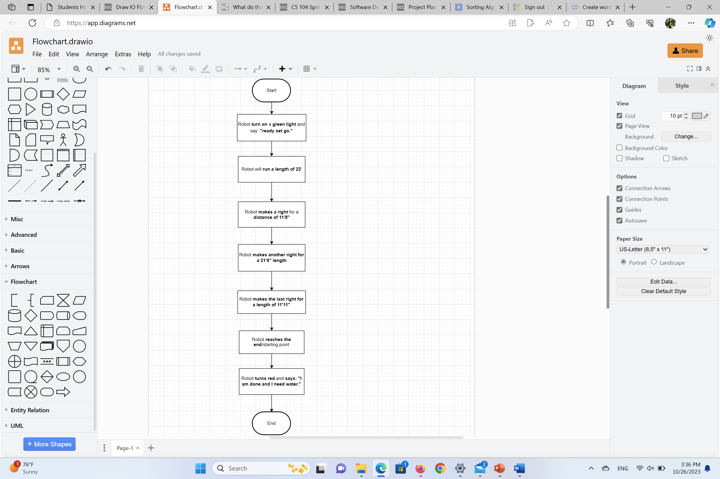

## Software

The official and supported Sphero EDU app was used to develop and run the code. The Sphero program utilizes block code (Shown below) to program the robots.

## Hardware

Laptops and desktops were used to develop the code and test the application on the Sphero BOLT robot.

## Test Plan

| **Reason for Test Case** | **Test Date** | **Expected Output** | **Observed Output** | **Staff Name** | **Pass/Fail** |
| --- | --- | --- | --- | --- | --- |
| Running a length of 22' | 10/31/23 | Robot is going to run down the length and stop after 22’ | When rolled directly on the line, came up short but when off the line it’s perfect length | Jon Veltri | Pass |
| Run the second length | 11/7/23 | Robot is going to turn the first corner and go down the second length. | The robot started going slightly to the left and stopped too late. | All | Fail |
| Run the second length | 11/7/23 | Robot is going to turn the first corner and go down the second length. | Robot accurately turned and ended in the correct position. | All | Pass |
| Run the third length | 11/7/23 | Robot is going to turn the second corner and travel down the third length. | Robot ran down the third length perfectly. | All | Pass |
| Run the Final length | 11/7/23 | Robot will turn down the final corner and travel down the last length on the line. | The robot stopped too early, and the coding needed to be adjusted. | All | Fail |
| Run the final length | 11/7/23 | Robot will turn down the final corner and travel down the last length on the line. | Robot turned the final corner and successfully made it to where it should start. | All | Pass |
| Test everything | 11/7/23 | The robot will complete the entire course and end where it started. | The robot stopped too early in one of the corners and started drifting away from the line. | All | Fail |
| Test everything | 11/7/23 | The robot will complete the entire course and end where it started. | The robot successfully went around the course once and said everything it had to. | All | Pass |

## Task List/Gantt Chart

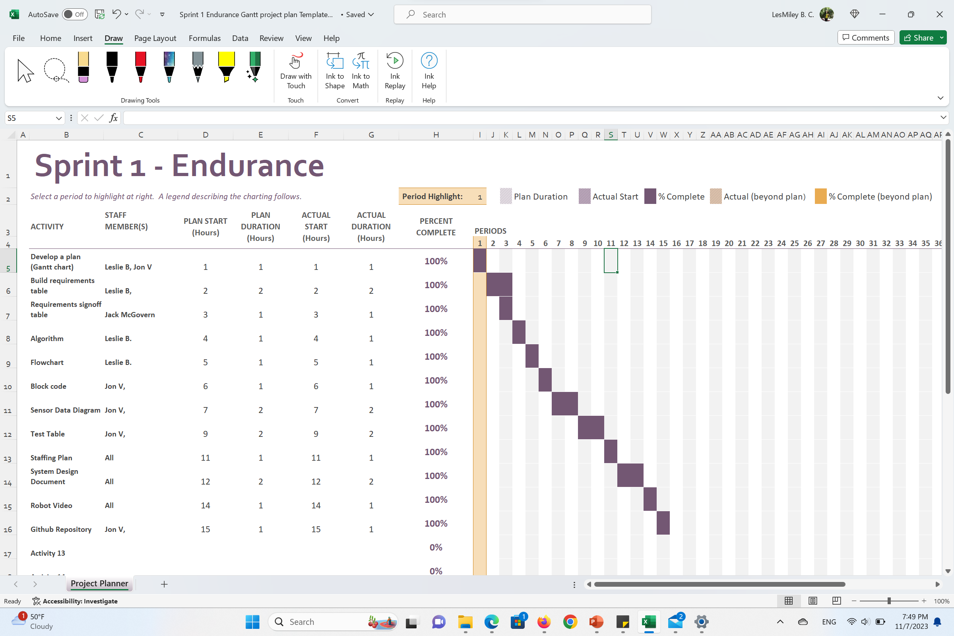

## Staffing Plan

| Name | Role | Responsibility | Reports To |
| --- | --- | --- | --- |
| Jon V. | Coding | Code the robot, setup the GitHub, record the robot video | Everyone |
| Jack M. | SDD | Fill in the missing information in the system design document | Everyone |
| Leslie B. | Gantt Chart / SDD | Fill in the missing information in the system design document; Also fill out the Gantt chart | Everyone |